Extracting publication numbers from EPOQUE Viewer

Adding citations (if necessary)
Before extracting publication numbers from EPOQUE viewer, you will need to import to the Viewer the publication numbers of any patent documents to be cited in the Search Report that have been sourced through freely available databases or other IT searching tools (i.e. not EPOQUE or STN) and that are not already present in the EPOQUE or STN search results that you will be extracting for the patent analytics report.

- Select Consultation>Manual Input from the top toolbar:

- In the Manual input box enter the publication numbers of patent documents to be cited:
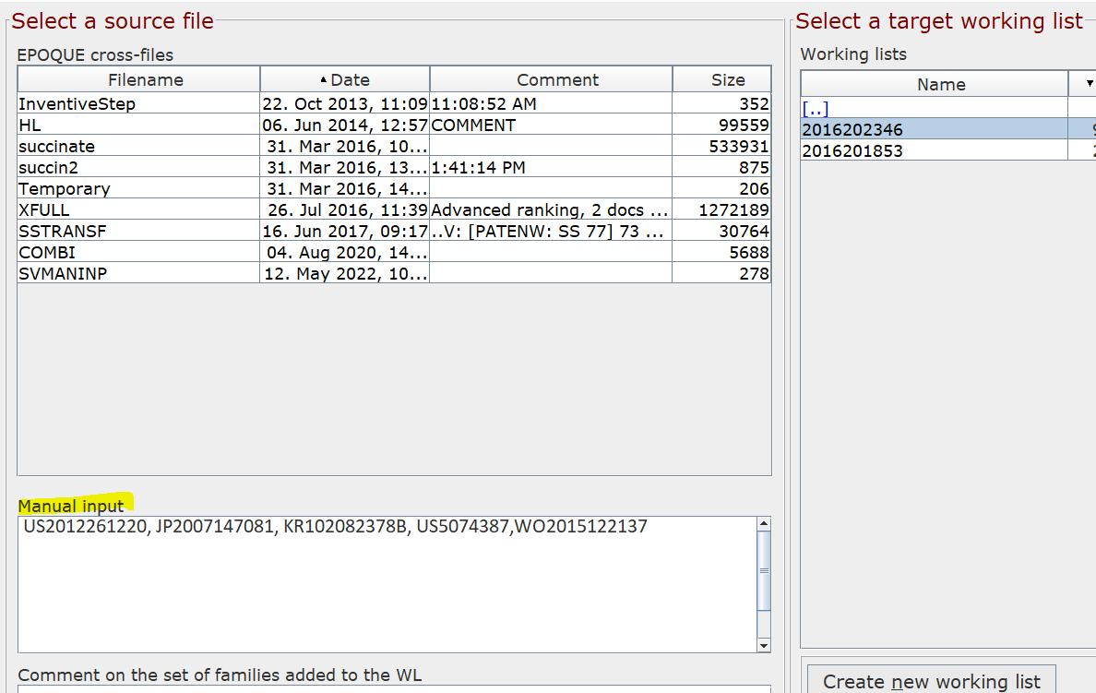

NOTE: US application numbers need to be entered in 10-digit format.

- Select the target working list where the EPOQUE search results for the case are located, ensure you have selected to ‘Append’, and click ‘Add & View’:
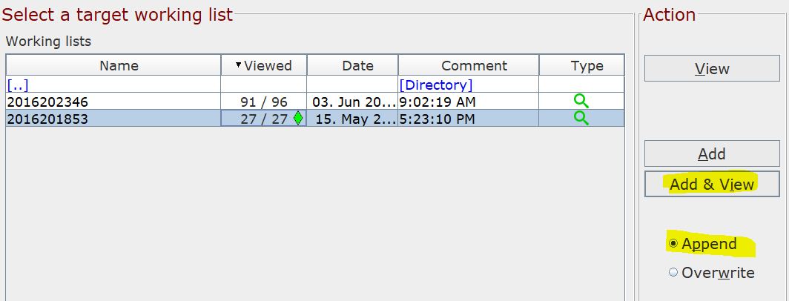

The manually added patent numbers will now appear in the History Drawer of the selected working list, along with viewed documents from the EPOQUE search:

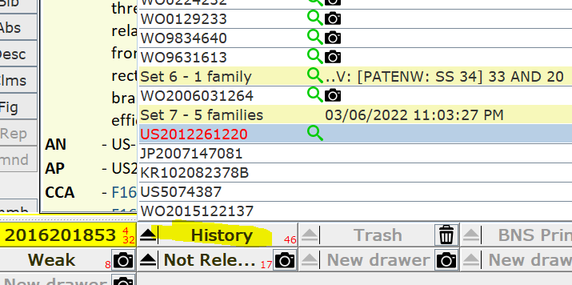

Extracting publication numbers

- Right click on “History” drawer to access the submenu (see figure below)

- Select “Copy” to copy the list of publication numbers to the clipboard
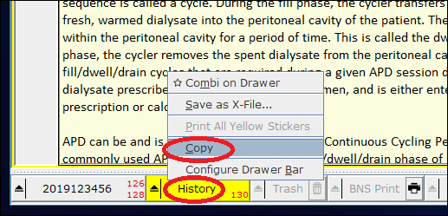

- Create an excel spreadsheet document

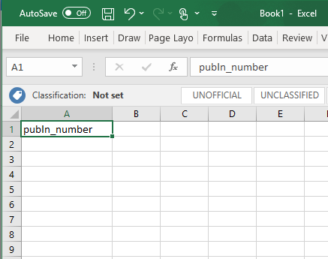
- In cell A1, type publn_number

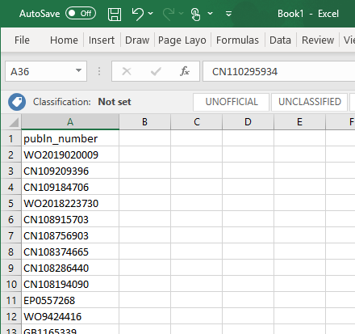
- Paste the retrieved EPOQUE documents in that column

- 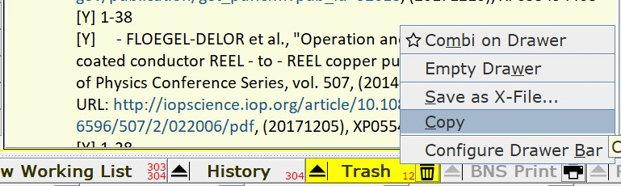If the “Trash” drawer was used, right click on it to access the submenu (see figure below), select “Copy” to copy the list of publication numbers to the clipboard and add these numbers to the spreadsheet document of step 5, below the numbers from the History drawer (NOTE: Examiners are advised never to empty the “Trash” drawer).

- Save your document as a CSV (Comma delimited) (*.csv) type
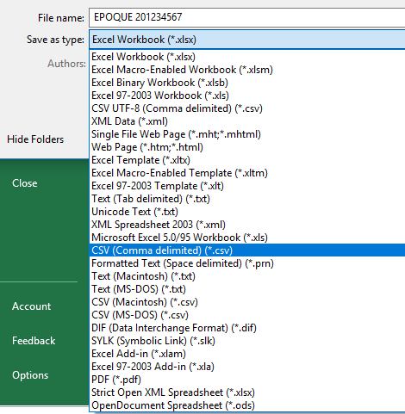

- Title your document in this format: “EPOQUE [CASE NUMBER].csv”

- Upload your document to the relevant case folder in COMPASS and send a notification email to the Patent Analytics Hub (MDB-Article155Analytics@ipaustralia.gov.au).

