Extracting patent information from STNext:

If you have displayed patent documents found in CAPLUS, WPIDS or other patent databases during the STN search conducted for the 15(5) application, please export the full transcript in standard RTF format with file name ‘STN [CASE NUMBER]’ and send to the Patent Analytics Hub (MDB-Article 15(5) Analytics) via email or upload onto COMPASS in the relevant case folder. Specifically:

1. before exporting the transcript, confirm patents are being displayed in STN format:
a. At the command line type ‘D SET PATENT’ and click submit:
=>D SET PATENT

b. Confirm that ‘STN’ appears as the current setting, i.e.

SET PARAMETER CURRENT PERMANENT LOGIN DEFAULT
------------- ------- --------- ----- -------
PATENT 'STN' 'STN' 'STN'

2. If the current setting appears as ‘DERWENT’, i.e.

SET PARAMETER CURRENT PERMANENT LOGIN DEFAULT
------------- --------- --------- ----- -------
PATENT 'DERWENT' 'DERWENT' 'STN' 'STN'

a. Change the setting to STN format by typing ‘SET PATENT STN’ in the command line and clicking submit:
=>SET PATENT STN

This will return output: ‘SET COMMAND COMPLETED’

b. Confirm that ‘STN’ appears as the current setting using the ‘D SET PATENT’ command:
=>D SET PATENT

SET PARAMETER CURRENT PERMANENT LOGIN DEFAULT
------------- ------- --------- ----- -------
PATENT 'STN' 'STN' 'STN'

3. If the search was performed with the patent display setting set to DERWENT format, the bibliography and abstracts of records from selected search lines will need to be re-displayed before exporting the transcript.

4. Once the bibliography and abstracts of records from search lines of interest have been displayed in STN format, navigate to the My Files>Transcripts:
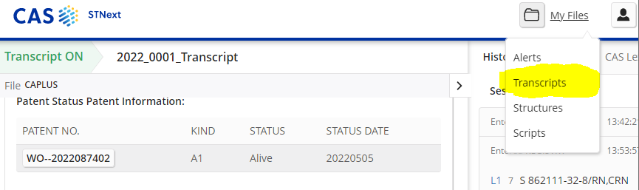

5.Select to download the full Transcript in standard RTF format:
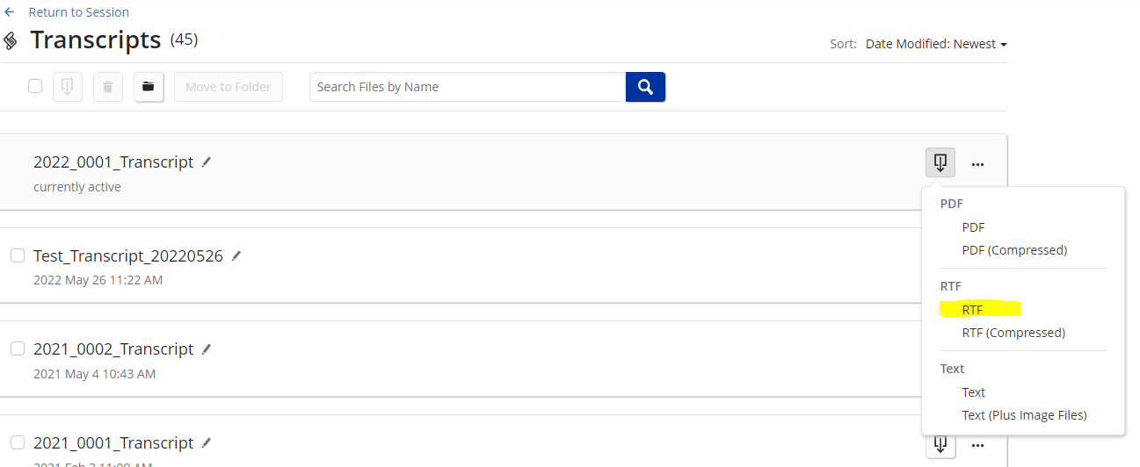

NOTE: The Patent Analytics Hub cannot process transcripts in PDF or TEXT formats, or in ‘enhanced’ or ‘compressed’ RTF format.

7. Title your transcript file in this format: “STN [CASE NUMBER].rtf”.

6. Upload the transcript file to the relevant case folder in COMPASS and send a notification email to the Patent Analytics Hub (MDB-Article155Analytics@ipaustralia.gov.au).

